Happiness
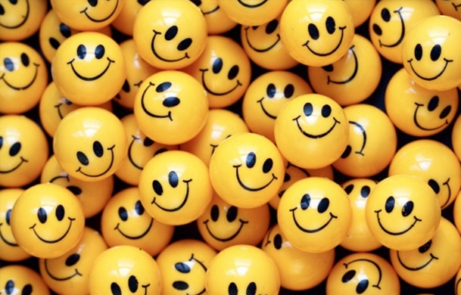
Where do you think do the world’s happiest people live? Somewhere hot with sandy beaches? A country with a tradition of fine food and culture? Not according to a recent study by the University of Leicester. In a list ranking the countries by the happiness of their citizens, it put tropical Fiji 50 places below freezing Iceland, and Canada far above France and Italy. And the happiest people on Earth? Those 5.5 million people call their home: Denmark.
Surprised? Well, you’ll be more surprised when you hear that the Danes pay some of the highest taxes in the world. Most Danes are used to seeing between 50-70% of their salary going to the government! So what is the secret to their success?
Let’s start with all that tax they pay. The Danish government provides its people with one of the finest education and health systems in the world. It spends more on children and elderly people per capita than any other country.
And there’s another advantage of those high taxes. Because a refuse collector’s final salary is not that much less than someone who works in a bank, for example, Danes don’t choose their careers based on money or status as people in other countries do. They choose the job they want to do. There’s a philosophy in Denmark known as ‘Jante-Iov’, which translates as ‘you’re no better than anybody else’. The refuse collector can hold his head up high as he proudly does his job – workers in other countries are not used to looking at life in this way.
Money doesn’t seem as important in Denmark. It has been called a ‘post-consumerist’ society. People have nice things in their houses, but they’re not mad about shopping and spending.
What is more important is the sense of society and it’s no surprise that the Danes are very used to socializing. They love hanging out with friends and family at gatherings called ‘hygge’. 92% of the Danes belong to some kind of social club and these clubs are even paid for by the government.
Finally, Danish people aren’t as suspicious as many other nations and show an amazing amount of trust in each other and their government. You can see signs of this all over the country: You’ll find vegetable stands with no assistant; You take what you want and leave the money in a basket. Parents leave their babies in prams outside the supermarket while they do the shopping. And Danes don’t need to lock their bikes up when they leave them to go into a shop. Perhaps the bike is a good symbol for Denmark. The Danes can afford cars, but they choose bikes – simple, economical, non-polluting machines that show no status and help keep people fit.
Questions
- What is the world’s happiest country?
- Name 4 reasons why the people who live there are so happy.
True or False?
- State Education isn’t very good in Denmark.
- Danish people see themselves as all being equal.
- Danish people don’t consider salary the most important part of the job.
- A ‘hygge’ is a formal family meeting.
- You don’t have to pay for food you take from vegetable stalls in Denmark.
- Bikes rarely get stolen in Denmark.

Discussion questions
- How could these things affect your life? Think of how happy they will make you: money – your job – your social life – weather
- Has your idea of happiness changed since you were a small child?
- What used to make you happy? And what makes you happy now?
- What would you like about living in Denmark?
- What would you dislike about living in Denmark?

How happy would these things make you? Give each item your own happiness rating: , , . Or mark them 1-10, 1 being the thing that makes you the happiest. Compare your answers with a partner.
- Meeting someone new and immediately knowing you are going to be great friends.
- Lying in a bath tub, soaking in the water, listening to some good music.
- Getting top marks at school.
- Turning off the alarm and going back to sleep.
- Having absolutely nothing to do and a whole day to do it in.
- Discovering a new band that nobody else knows about.
- Laughing out loud with your best friend.
- Being independent and making your own choices.
- Having sunshine every day.
- Earning more than 10€ per hour.

Fill in the gaps
Choose from: global warming – drought – floods – deforestation – overpopulation - heat wave - greenhouse effect - depletion of resources - endangered species - water shortage

Most of the environmental problems we face today are the result of (1)_____________ . The planet simple can’t cope with the pollution caused by 7 billion people. Consequently, the natural (2)_____________ is being strengthened causing (3)_____________ .
This phenomenon is changing our climate. While (4)_____________ is becoming a serious problem is such places such as Africa, (5)_____________ are becoming more several in Europe. Nevertheless, excess rain isn’t the only problem facing Europe. There are also many (6) _____________ in summer with temperatures reaching 40ºC.
This growing population has many needs which means that there is a (7)_____________ on a planetary level. (8)_____________ not only causes air pollution and erosion, but also threatens many (9)_____________ such as pandas and tigers.
In my opinion, however, the biggest problem we face is (10) _____________ unless we find a way to efficiently recycle salt water. if not, wars will surely be fought over this precious, but limited, resource.

